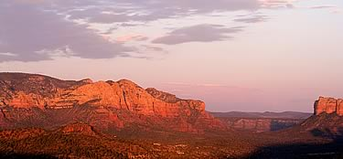

Sedona Arizona Run
8th to 10th of April

Chris and Dave Hunter are going to Sedona AZ. to take in the sights and enjoy a relaxing ride. Anyone that wishes to join us is welcome.
The original four-day trip to Sedona Az. has been trimmed back to a three-day trip.

We will leave from the Ridgecrest Jack-in-the-Box at 0700 on Friday the 8th of April. A breakfast stop is planned in Barstow.

Generous fuel and rest stops are planned and will be modified as needed to conform to the groups needs.

We plan on staying in at the Super 8 Motel in Sedona. I called ahead and they are motorcycle friendly and will provide parking near the front desk.

Saturday Morning we have tickets for the Verde Canyon Railway tour. Currently we have tickets for first class. Saturday afternoon is unplanned at this time.

We will return on Sunday with a leisurely ride through the local area and old route 66 on our way back to Ridgecrest.

Rooms and Train tours are still available as of 3/30.
If you plan on joining us I recommend that you make your reservation for the Hotel and train trip in Sedona soon as they may sell out.

Please let me know if you think you are going so we will not depart without you.

Dave. LDSW13@yahoo.com
For more info about Sedona.
http://www.visitsedona.com/
http://www.gatewaytosedona.com/
http://www.sedona.net/


http://www.sedonasuper8.com/


http://www.verdecanyonrr.com

