CABIN FEVER RUN 06!
IT’S THAT TIME AGAIN!

WHERE: Beatty NV.
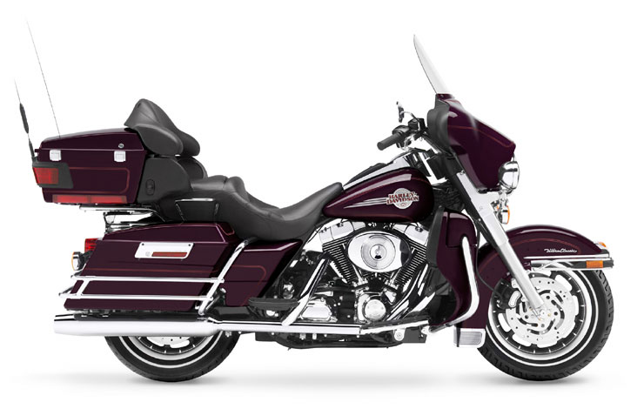
WHEN: Sat. 4 Feb 2006
Depart: 0900 Sat. Chevron Station Ridgecrest Blvd.
Return: Sun 5 Feb. when you wish.

Rooms: Stage Coach Hotel 1-800-424-4946 or 775-553-2419
Motel 6 1-800-466-8356 or 775-553-9090

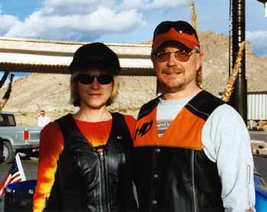

The folks who started the Fever Run invite you to come again to beautiful Beatty. Thanks Bland and Billie.

Don’t forget the hot springs for H a hot swim. So bring your swim suits.

