25-28 June 2010

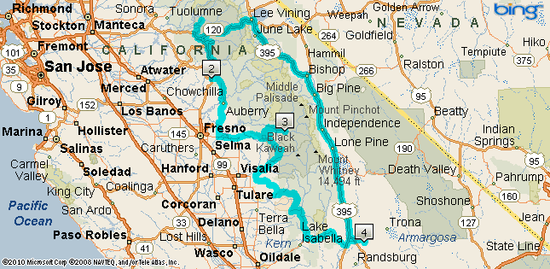
I had a great plan together for this ride to Yosemite, King’s Canyon and Sequoia National Parks this year. The ride would be spread over four days and encompass about 1000 miles round trip. As everyone knows, plans as a rule don’t always go according to Hoyle and this trip would be no exception.

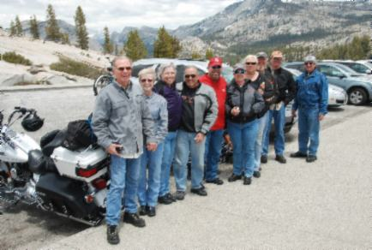
There were several riders going together to Yosemite from our local Harley Owners Group, then we all would split up and go separate ways. Those that stayed together ended up riding back together for the most part. Along the way, John a friend from work, and I stopped at June Lake to pay another friend a visit. Soon after our visit, we were back on the road around the loop, heading to the Mobil station on I-120 (Tioga Pass road) where we caught up with the rest of the group for lunch. The pork tenderloin and carrot cake were fabulous. Next, we headed into Yosemite and stopped at Olmsted Point where we could view Half Dome from the back side and got the usual group photos.

After the brief stop, John and I left the group and headed over to see Hetch-Hetchy Reservoir and the O’Shaughnessy Dam. The rest of the group headed to Oakhurst, where we would catch up to them for dinner later.

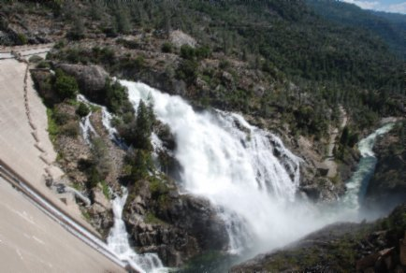
The ride to Hetch-Hetchy was excellent and the dam and reservoir were amazing. There was a lot of water coming over the spillway which turned into a roaring torrent that shot out over the side of the gorge below in an amazing waterfall and spray that created rainbows and mists that coated the other side of the canyon and fell back into the gorge in a thousand trickling waterfalls. This side trip was well worth the extra time to see. After getting some great photos, John and I then headed toward Oakhurst, our destination.

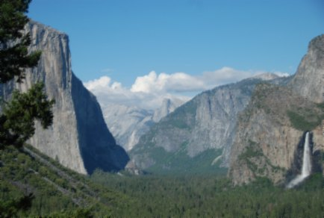
We stopped at the tunnel overlook for some quick pictures of Yosemite Valley and immediately headed out. I entered the tunnel first and gunned it, creating a deafening roar that I later heard had startled the tourists. When I looked back to see if John was following, he wasn’t. I slowed down and he caught up soon thereafter. Later he confessed his delay, but that is his story. Feel free to imagine what might have delayed him. The road from the tunnel to the south park entrance/exit is under construction. Traffic was heavy and slow and there were several places where the pavement turned into gravel. I was happy my travel plans would not be taking me back over that road again. We arrived at the hotel in Oakhurst and met up with the rest of our group for some great Italian cuisine.

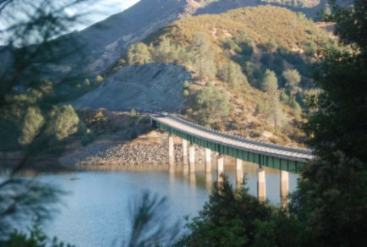
For Saturday, some of the group were going to take the tram around Mariposa Grove and see Glacier Point, but since I’d been there a couple times already, I decided to do something different. I planned to leave Oakhurst and head north on I-49 to I-4 (Ebbett’s Pass). Take that to Markleeville, then take I-89 north to I-88 (Kit Carson Pass) west and take that down to I-49, back to Oakhurst. Part of that worked right. Then things changed.

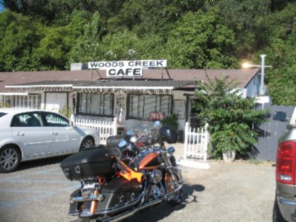
John went with me and we made it easy to Jamestown on I-49, near where I-4 and I-108 converge. We stopped for a late breakfast. The little café was full of people, but the food came fast and was very good. We finished up and began to leave. Pulling out of the parking lot was more of a challenge than I could manage in the gravel and I tipped my bike over. John quickly helped me get vertical again (seems I forgot the shiny side up rule). I suppose there are now some scratch marks on the bottom side of the crash bars, but I haven’t looked. Other than that, there was no damage and we continued on our way.

We next took I-4 east toward Markleeville. Nice road with lots of sweepers, minor traffic, beautiful scenery. The pines and mountains covered in snow were awesome. Toward the summit the sweepers turn into some tight twisties. We stopped at Bear Valley to gas up. This area is in the middle of a beautiful valley with several small lakes. After cresting Ebbett’s Pass, we stopped for some pictures at a beautiful lake where fisherman were catching quite a few trout. Then we continued on to Markleeville, where the first change to the plan occurred.

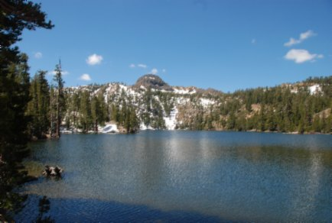
Looking at the remaining tread on my front tire, I thought I might be pushing it to expect to complete the trip with spare tread. Looking at the GPS, I figured it was only about 40 miles to the Harley shop in Carson City. John agreed to the plan change and off we went. This was just the first change of plans. We got to the shop about 1330 and they quickly got the bike into the service shop to have new tires installed. After having black side walls for a while, I decided to go back to the wide whitewall models. The shop gave me a good deal on a set of Dunlop 402s and they said they would be done in a couple hours. I figured that would give us enough time to get back to Oakhurst before dark, but my figures would turn out to be wrong. The mechanic told me that my front wheel was out of round and that I should come check it out. He showed me on the balancer that it was. It looked bad, so I asked him to fix it. He was able to get if back within spec in short work and we were back on the road at 1630. This was a little later than I expected, but it could not be helped.

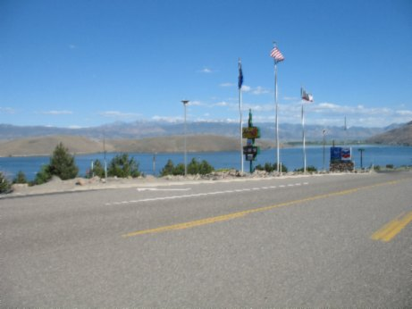
We decided it would be best to head down I-395 to Sonora Pass (I-180) and take that back to I-49. Neither of us wanted to negotiate the road under construction through Yosemite again, especially if it would be in the dark. So we headed south on I-395 toward Topaz Lake and past Walker and took Sonora Pass. What a challenging route Sonora Pass is! Steep 26% grades on the way up, tight windy curves, traffic including a bus or two and a truck being pushed by a trailer, gave our bikes and us a real workout.

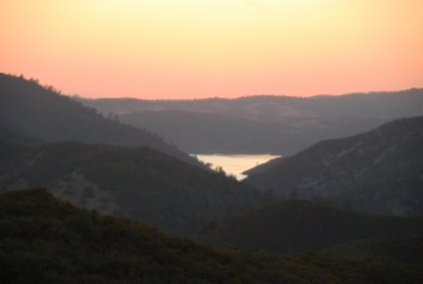
After cresting Sonora Pass, we came into some thick forested areas, mountains covered in snow, streams running by the side of the road and open meadows. There were plenty tight twisties and sweepers to enjoy. After all this, the road opened up and became very smooth, with gradual sweeping turns right and left that we could easily negotiate at 60 mph or so. We rode these sweepers for about an hour or so. It was amazingly fun and traffic was non-existent. About Coulterville on I-49 it got dark. We finally made it back to Oakhurst about 2130 and had a late dinner at a great little Chinese place. In all, an excellent day’s ride, the new tires made the ride effortless and the change of plans worked out as well as could be.

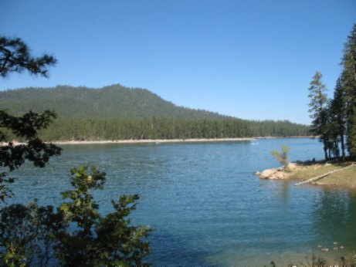
Sunday morning we got up, ate breakfast and headed for King’s Canyon. Not the straight shot you might imagine down I-41, we took some of the back roads. We went around Bass Lake then took Auberry down to I-180 and on to King’s Canyon. Arguing with the ranger about what the Annual Pass covers and doesn’t cover is a waste of time. John paid his share and later said my argument with the ranger was worth the admission price.

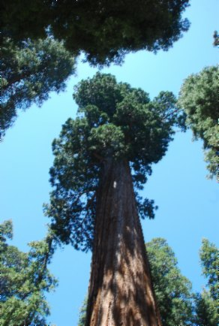
We stopped at Grant Grove and walked around some of the biggest trees in the world. The President Grant Tree is about 300 feet tall. There were many others that from my vantage point were all the same, huge. Next we entered the canyon and found lots of sweepers and twisties. We stopped at the King’s Canyon Lodge for some refreshment. Here they have the oldest still working gravity gas pumps in the World probably. They date back to 1929, six gallon minimum purchase, but they have regular and premium. Next we stopped at Grizzly Falls and took some more pictures. I got a few photos of the King’s River as we were riding next to it on our right. The King’s River is a thundering torrent of water racing through the canyon at amazing speed. Our next stop was Roaring Falls. Not a very high falls, but the amount of water coming down this falls is inestimable. To say it’s a lot does not begin to describe how much water comes over this little falls. We headed over to the Cedar Grove Lodge, our destination for the night. The presentation by the ranger on bears was entertaining, but geared toward kids. Still it was the only show in the canyon since there are no TVs in the rooms at the lodge. Also there is no cell phone coverage and WiFi is very limited.

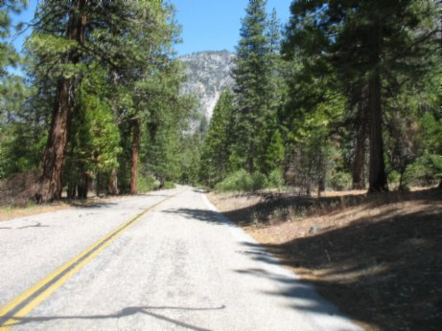
Monday we headed out of the canyon for Sequoia and our return home. At Hume Lake we gassed up and had a snack for breakfast. They only had 87 octane gas, but the store sells octane booster. As we were climbing out of King’s Canyon I noticed John’s back tire flashing white with each revolution. At Hume Lake, I looked closer and pointed out to John that he had already worn through the first set of cord on his back tire. Although John thought his tires would last for the trip, his back tire had a different idea. It had had enough. It was time for plan change number two.

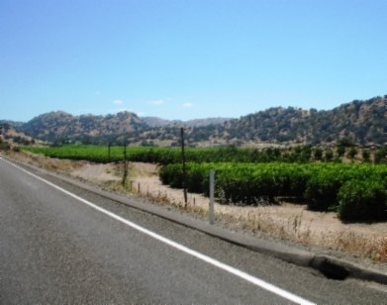
No matter, I’d seen all of Sequoia before so this change was no big deal. I reprogrammed the GPS for Visalia where I knew there was a Harley Shop. We made it to the shop okay, but it was closed. We found a cycle place that had a tire for John’s bike and a guy close by that could install it. Man was it hot in Visalia and the humidity was up as well. John and I walked to a nearby taco shop for lunch. When we got back the bike was done. With the tire installed we took off, when John noticed his back brake did not work. We returned to the guy that installed the tire. After working on it for some time, the determination was that his master cylinder had gone out and adjusting the caliper just a little to reinstall the brakes during the tire change, was enough to affect the operation of the back brake. Bleeding the brakes did not work. There was nothing for John to do but ride home with no back brake. I soaked and donned my hydro vest as did John. John had some trouble not being able to use his back brake, so we took it slow. John felt he was slowing me down and asked me to continue on without him. I wanted to make sure he made it back okay, so I stuck with him.

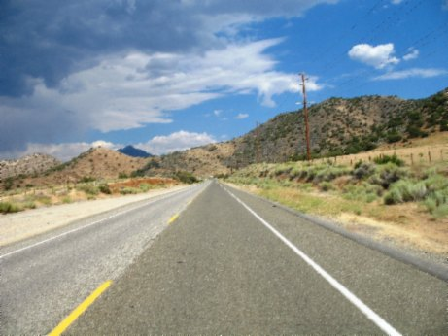
We got to Bakersfield where the Harley Shop was again closed. We gassed up and John insisted I go ahead alone. I did not want to leave him, but he insisted he did not want me to follow him and that he would be okay. It was time for plan change number three. I felt bad that John did not want me to ride with him, but I wasn’t going to follow him if he didn’t want me to. I headed off without him to I-178 east through the Kern River Canyon. There was hardly any traffic. The temperature got cooler with the altitude change and cloud cover. I took some more photos of the ride back through Kern River Valley and coming down from Walker Pass. I had a pleasant ride and made it back about 1730. It’s always a good idea to have a ride plan, but this trip I found out I need to be flexible for a number of reasons. The number in this case was three. In all I logged over 1300 miles.

Tom Lystrup

