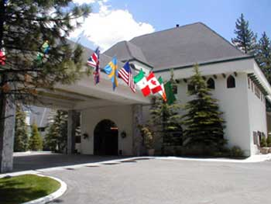

Address:
42200 Moonridge Road, Big Bear Lake, California, 92315, US

Phone: 909-866-6666 | Fax: 909-866-8988
Toll Free Reservations: 800-232-7466

Welcome to Best Western Big Bear Chateau!
Full package information with prices is listed on the hotel amenities page.
The Best Western Big Bear Chateau is centrally located between Bear Mountain and Snow Summit Ski Resorts.
This full service hotel includes an award-winning restaurant and lounge. All 80 non-smoking rooms offer fireplaces, pillow top beds, and oversized bathrooms. Many rooms feature Jacuzzi bathtubs. Our extensive amenities include a heated outdoor whirlpool and swimming pool, sauna, fitness room, coffee/tea maker, dataports, hairdryer, air-conditioning, iron and ironing board. Our experienced banquet staff can help you make your meeting, wedding, or social event a true success. Our meeting rooms can accommodate up to 200 guests and offer audio/visual equipment, exhibit services, computer equipment, Internet connectivity, and shipping.
Nestled 7,200 feet in Big Bear Lake's pine forest, the Best Western Big Bear Chateau is the perfect choice for your mountain getaway.

General Hotel Information:
Check-In: 4PM (16:00)
Check-Out: 12PM (0:00)
Hotel Ratings: AAA-3 Diamonds , Mobil-2 Star
Pet Policy: Pets allowed with No Restrictions $30.00 the first night, $15.00 for each additional
More >

Guest Rooms:
Cable satellite television with
basic channels and Showtime
Coffee/tea maker
Dataports
Free local calls under 30 minutes
Voice mail
More >

Area Information:
0 mile(s) from on-call massage
services
.5 mile(s) from hiking/walking trails
.8 mile(s) from Snow Summit, ski
resort
1 mile(s) from barber/beauty shop
1 mile(s) from sun bed

Features & Amenities
Hot Tub
Fitness Center/Health Club
Pool
Pets Allowed
Restaurant On-Site/Nearby
Room Service
High Speed Internet

